PPL LAB 1
name: Abhinav Singh Bhagtana
Section: CSE-A1
roll no: 29

Q1.
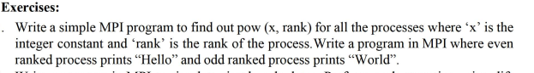
/*
print pow(x,rank) where x is a constant. even rank processes print hello, odd print world.
author: Abhinav Singh Bhagtana
date: 9 Jan, 2026
run cmds:
mpicc q1.c -o q1 -lm
mpirun -n 4 ./q1
*/
#include <mpi.h>
#include <stdio.h>
#include <math.h>

int main(int argc,char *argv[])
{
int x = 10;
int rank,size;
MPI_Init(&argc,&argv);
MPI_Comm_rank(MPI_COMM_WORLD,&rank);
MPI_Comm_size(MPI_COMM_WORLD,&size);

printf("Process %d calculates: %f and says ",rank,pow(x,rank));
if(rank % 2 == 0)
printf("Hello\n");
else
printf("World\n");

MPI_Finalize();
return 0;

}
OUTPUT:
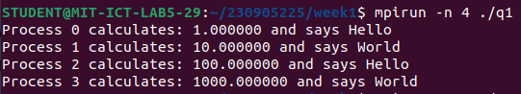

Q2.
/*
write a simple calculator using mpi where different thread does different operations
author: Abhinav Singh Bhagtana
date: 9 Jan, 2026
*/
#include <stdio.h>
#include <mpi.h>

int main(int argc,char *argv[])
{
int a=543,b=234,rank;
MPI_Init(&argc,&argv);
MPI_Comm_rank(MPI_COMM_WORLD,&rank);

if(rank == 0)
printf("Process %d: %d + %d = %d\n",rank,a,b,a+b);
else if(rank == 1)
printf("Process %d: %d - %d = %d\n",rank,a,b,a-b);
else if(rank == 2)
printf("Process %d: %d * %d = %d\n",rank,a,b,a*b);
else if(rank == 3)
printf("Process %d: %d / %d = %f\n",rank,a,b,(float)a/b);
else
printf("this thread does not do anything");
MPI_Finalize();
return 0;
}
OUTPUT:
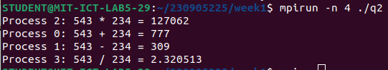
Q3.
/*
toggle the case of the character in a string indexed by the rank of the process.
author: Abhinav Singh Bhagtana
date: 9 Jan,2026
*/
#include <stdio.h>
#include <mpi.h>
#include <string.h>
#include <ctype.h>

int main(int argc,char *argv[])
{
char string[] = "HeLlOw";
int rank,size;

MPI_Init(&argc,&argv);
MPI_Comm_rank(MPI_COMM_WORLD,&rank);
MPI_Comm_size(MPI_COMM_WORLD,&size);

if(size > strlen(string))
{
printf("more processes initialized than length of string");
MPI_Finalize();
return 0;
}

if(isupper(string[rank])){
string[rank] = tolower(string[rank]);
printf("Process %d: %s\n",rank,string);
}else{
string[rank] = toupper(string[rank]);
printf("Process %d: %s\n",rank,string);
}
MPI_Finalize();
return 0;
}
OUTPUT:
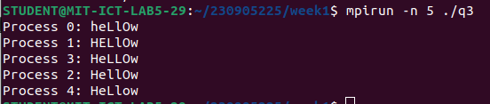
Q4.
/*
even process prints factorial of rank and odd process prints rank fibonacci number
author: Abhinav Singh Bhagtana
date: 9 Jan,2026
*/
#include <mpi.h>
#include <stdio.h>

int fact(int n)
{
int f = 1;
for(int i = 1;i <= n;i++)
f *= i;
return f;
}

int fib(int n) {
if (n <= 1) return n;

int a = 0, b = 1, c;
for (int i = 2; i <= n; i++) {
c = a + b;
a = b;
b = c;
}
return b;
}

int main(int argc,char *argv[])
{
int rank;
MPI_Init(&argc,&argv);
MPI_Comm_rank(MPI_COMM_WORLD,&rank);

if(rank % 2 == 0)
printf("Process %d: factorial of %d = %d\n",rank,rank,fact(rank));
else
printf("Process %d: %d fibonacci number = %d\n",rank,rank,fib(rank));

MPI_Finalize();
return 0;
}
OUTPUT:
